

纳米系统与多级次制造实验室 学术报告

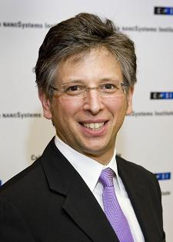

时间：6月24日 14:00

地点：南楼二层会议室

**Professor Paul Weiss**

Fred Kavli Chair in NanoSystems Sciences, Chemistry

Distinguished Professor of Chemistry & Biochemistry, Materials Science & Engineering

California NanoSystems Institute, University of California, Los Angeles

**Education:**

Ph.D., University of California, Berkeley, 1986   
S.M., Massachusetts Institute of Technology, 1980   
S.B., Massachusetts Institute of Technology (M.I.T), Cambridge, MA, 1980

**Cooperative Function in Atomically Precise Nanoscale Assemblies**

We use molecular design, tailored syntheses, intermolecular interactions, and selective chemistry to direct molecules into desired positions to create nanostructures, to connect functional molecules to the outside world, and to serve as test structures for measuring single or bundled molecules. Interactions within and between molecules can be designed, directed, measured, understood, and exploited at unprecedented scales. Such interactions can be used to form precise molecular assemblies, nanostructures, and patterns, and to control and to stabilize function. We selectively test hypothesized mechanisms by varying molecular design, chemical environment, and measurement conditions to enable or to disable function and control using predictive and testable means. Critical to understanding these variations has been developing the means to make tens to hundreds of thousands of independent single-molecule/assembly measurements in order to develop sufficiently significant statistical distributions, while retaining the heterogeneity inherent in the measurements. We measure the electronic coupling of the molecules and substrates by measuring the polarizabilities of the connected functional molecules. The next step in such devices is to learn to assemble and to operate molecules together, both cooperatively and hierarchically, in analogy to biological muscles. We discuss our initial efforts in this area, in which we find both interferences and cooperativity.